8.SOFTWARE PERSONAL MANAGEMENT SYSTEM

COLLABORATION DIAGRAM

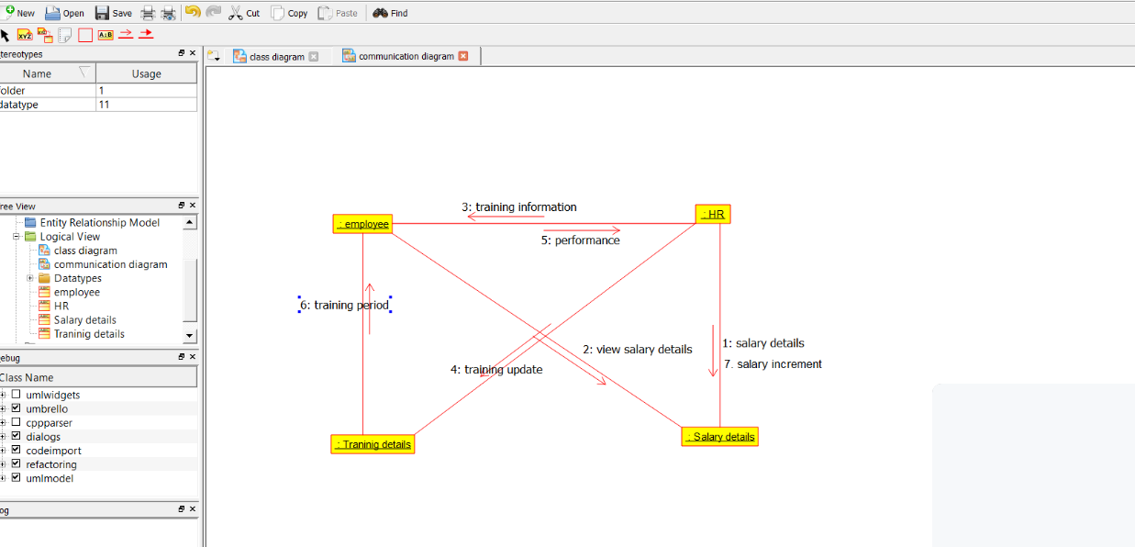

CLASS DIAGRAM

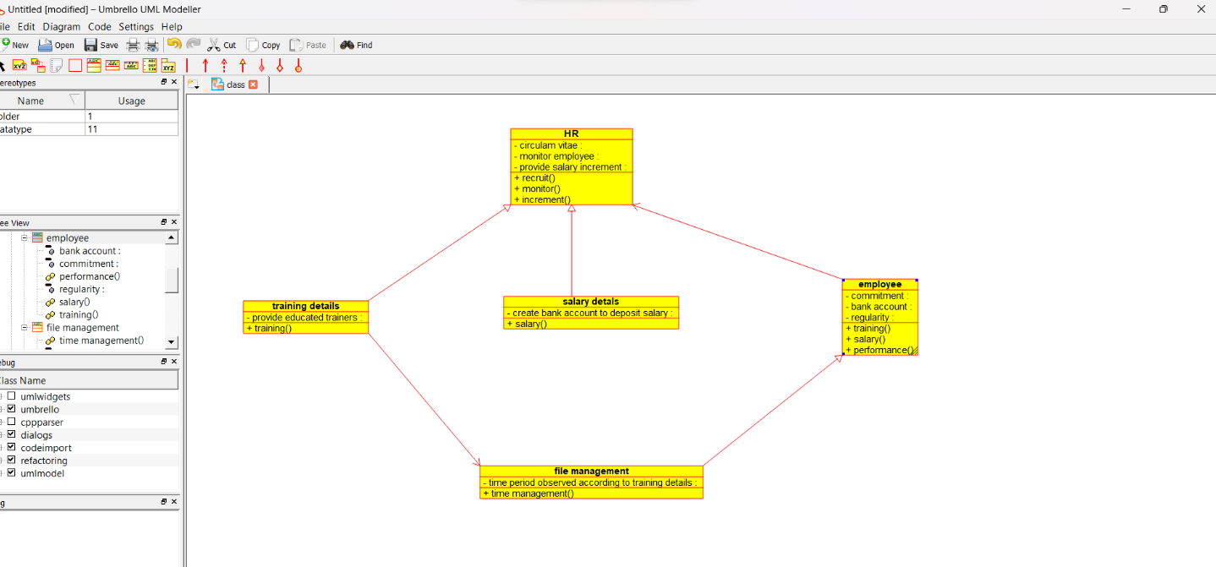

DEPLOYMENT DIAGRAM

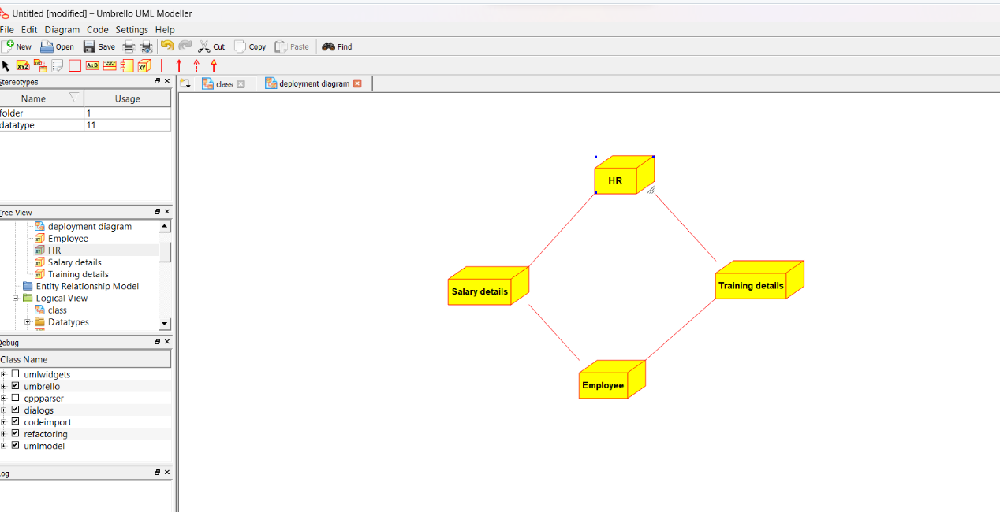

USECASE DIAGRAM

